# Homework 2: Mastering the Basics of SQL Server

(**Task 1: 5 points**) Complete Task #2 through Task #4 while placing your sql files in Queries. Show in a screenshot that your Homework 2 project in Solution Explorer contains **three** sql files in **Solution Explorer**.

**(Task 2: 5 points**) Show in a screenshot that **DatabaseLog_test** table is created in **MyDatabase2**, and **not** in **MyDatabase1**.

(**Task 3: 4 points**) Create the three temp tables listed above and show their existence using the SELECT command above. Attach a screenshot.

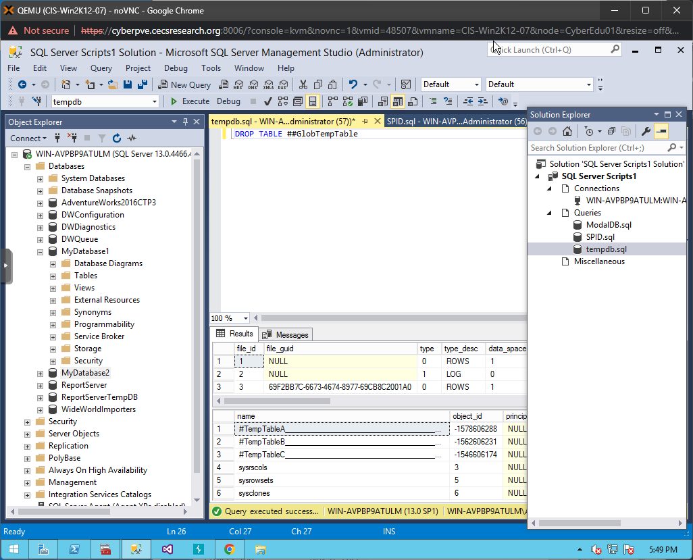

(**Question: 1 points**) When do we use temporary Tables? List two scenarios. When do we use table variable over temp table?

*Scenario 1: Temp tables can be used if you want full DDL or DML access to a table but don’t have the access. You can use existing read access to pull the data into a SQL Server temporary table and make adjustments from there.*

*Scenario 2: You don’t have permissions to create a table in the existing database, you can create a SQL temporary table that you can manipulate. You might also need the data to be visible only in the current session.*

*A temp table is a temporary table, which is exactly what it sounds like. Table variable are declared variables that are only used and accessible within the session that created them and only within the current batch. They’re not visible outside the batch so hierarchy can be ignored.*

(**Task 4: 5 points**) Fill in **all** the blanks. Keep in mind that you have made a connection via a dynamic port not the default number. Your answers to the second column must be consistent with the connection you made.

***Followed all directions but the dialog box showing “SQL Server” connection properties does not appear after restarting the sqlserver via the configuration manager.

This is the only box that shows up. I’ve tried everything I can thnk of but no connection option opens up like the one in the directions shown.

|  |  |  |
| --- | --- | --- |
|  | **Name/Number** | **Description (definition)** |
| SPID | 56 |  |
| SID |  |  |
| principal_id | 271 |  |
| net_library | LPC – I know its wrong but I put the code. Not sure what’s wrong. |  |
| local_tcp_port | Shows “null” |  |

In addition, show the result of each of the four queries in a screenshot.

***SPID –*** ***Ran the code and found SPID as 56. Likely not correct but ran for good faith effort.***

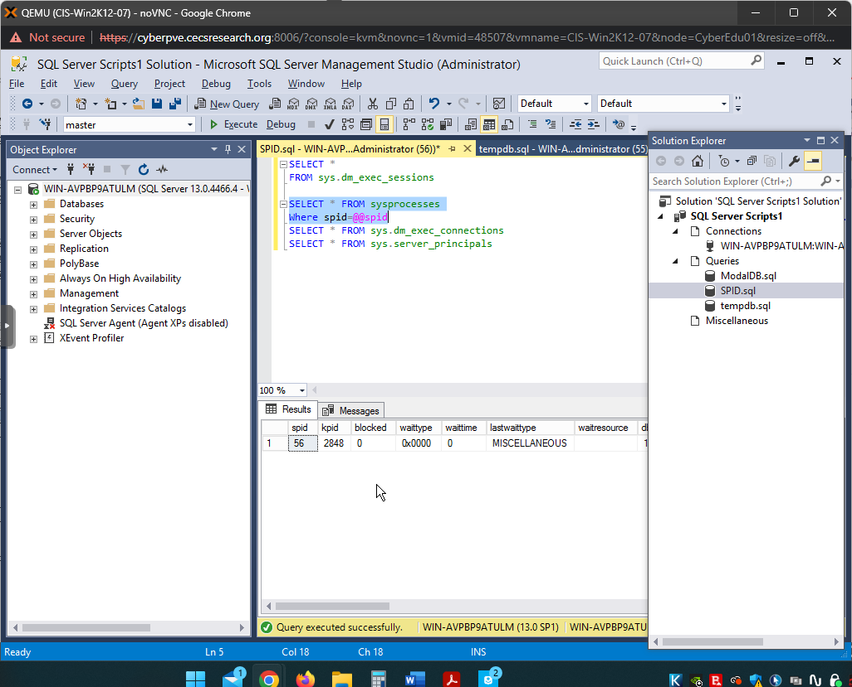

***SID – I ran the code anyway, as previously stated, and found ne_library. It’s not TCP/IP but, again, trying to show effort.***

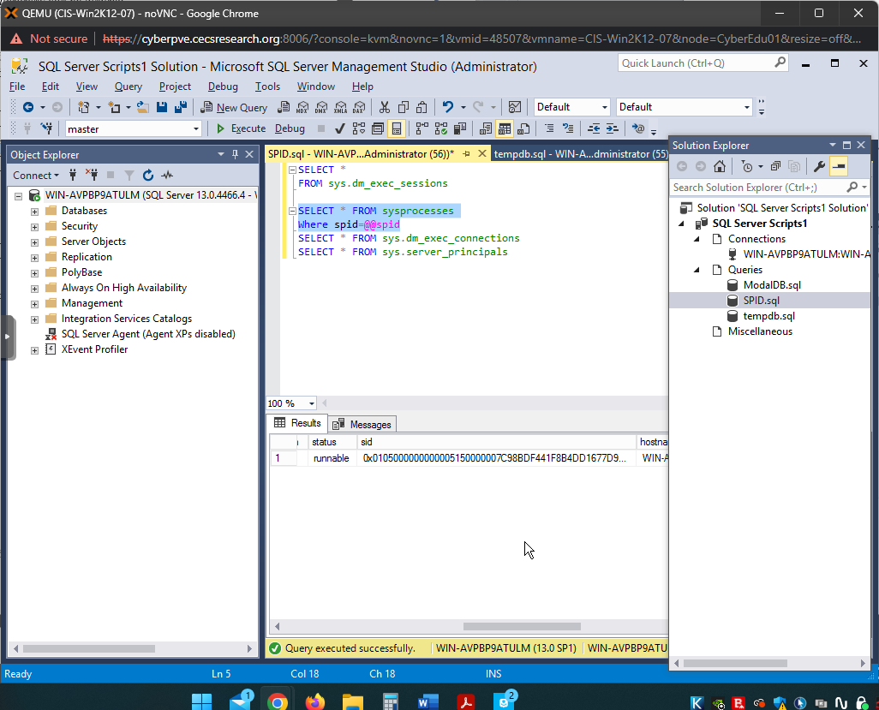

***NET LIBRARY – Found as LPC, wrong but showing effort.***

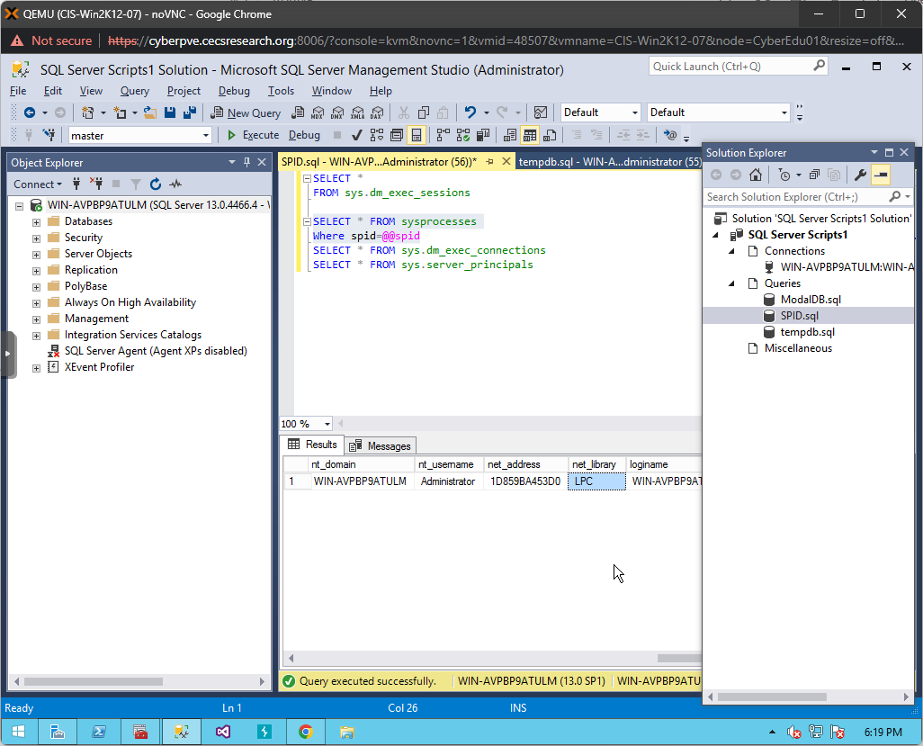

Principal_id –

***LOCAL TCP PORT*** ***– It’s not 30000 but null due to the connection not being TCP/IP as described previously. Still ran the script to show effort.***

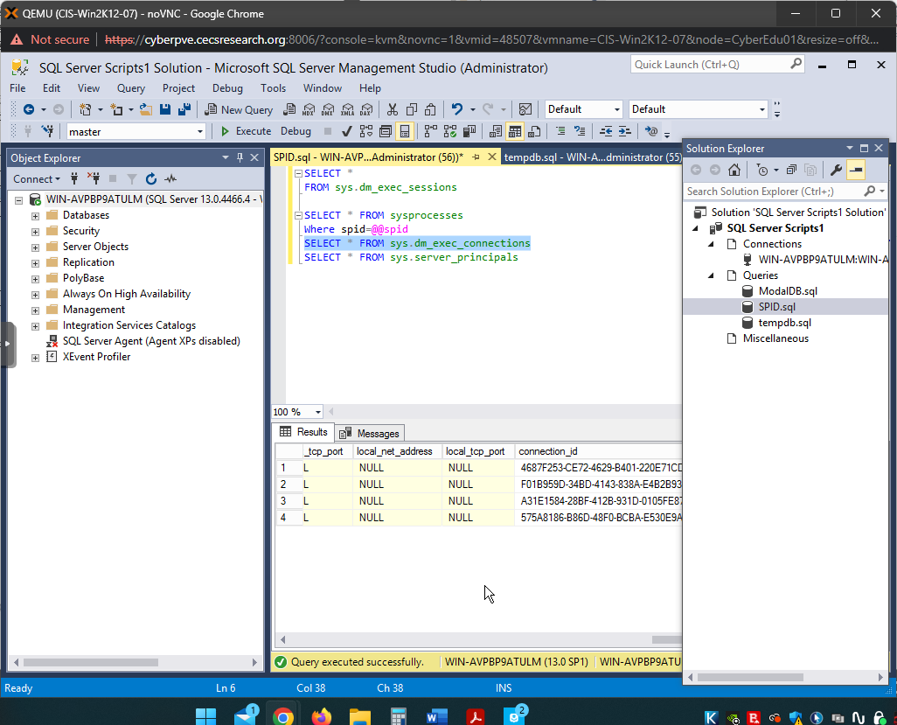

***Principal_id – 271 via image. Still wrong connection, showing effort.***

